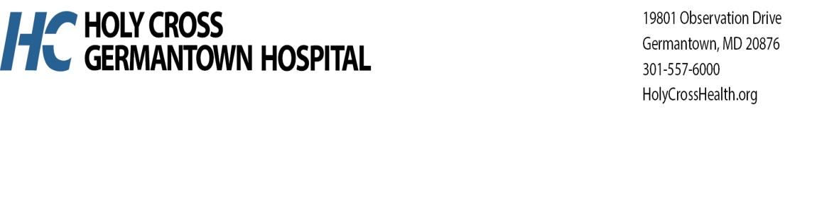

**2025 MEDICAL EXECUTIVE COMMITTEE**

**President:** *Jahangir “John” Rouhani, M.D*.

**Vice President:** *Aliya Poshni, M.D.*

**Secretary Treasurer:** *Rohit Khirbat, M.D.*

**Credentials Chair:** *Halim Charbel, M.D.*

**Medicine Chair:** *Sameer Ismailjee, M.D.*

**Surgery Chair:** *Tariq Nayfeh, M.D.*

**OB/GYN Chair :** *Yolande Robertson-Hackney, M.D.*

**Pediatric Chair:** *Simran Kalra, M.D.*

**Emergency Department Chair:** *Ann Price, D.O.*

**Anesthesia Chair:** *Roger Shere-Wolfe, M.D.*

**Holy Cross Health Representatives**

*Chief Nursing Officer -* ***Kim Elliott, CNO.***

*Chief Medical Officer, Holy Cross Health -* ***Lina Hong, M.D.***

*Interim Chief Clinical Officer Holy Cross Health -* ***Janis Green, M.D., MBA.***

*Interim President, RHM President Holy Cross Health -* ***Reginald Eadie, MD, MBA***

*Regional President and CEO, Trinity Health Mid-Atlantic and Holy Cross Health in Maryland -* ***Andre Boyd, FACHE.***