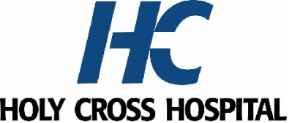

**2025 MEDICAL EXECUTIVE COMMITTEE**

**President:** *Gregory Mathews, M.D.*

**Vice President:** *Kanwaljit Nagi, M.D.*

**Secretary Treasurer:** *Rami Makhoul, M.D.*

**Credentials Chair:** *Zachary Levine, M.D*.

**Medicine Chair:** *Theodore Igwebe, M.D.*

**Surgery Chair:** *Nini Khozeimeh, M.D.*

**OB/GYN Chair:** *Alicia Odum, M.D.*

**Pediatric Chair:** *Stephanie Perdue, M.D.*

**Emergency Department Chair:** *Holley Meers, M.D.*

**Pathology Department Chair:** *Pablo Gutman, M.D.*

**Radiology Chair:** *Benjamin Stallings, M.D.*

**Anesthesia Chair:** *Marc Azran, M.D.*

**AT LARGE**

**Surgery:** *Antoni Goral, M.D.*

**Pediatric:** *Chrysanthe Gaitatzes, M.D., PhD.*

**Medicine:** *Rachel Vile, M.D.*

**OB/GYN:** *Vera Ibe, M.D.*

**Holy Cross Health Representatives**

*Maggie Perih, RN, MSN, Chief Nursing Officer*

*Janis Green, M.D, Interim Chief Clinical Officer, Holy Cross Health*

*Janis Green, M.D., Chief Medical Officer, Holy Cross Hospital*

*Reginald Eadie, M.D., Interim President, Holy Cross and Holy Cross Germantown Hospitals*

*Andre Boyd, FACHE, Regional President and CEO, Trinity Health Mid-Atlantic and Holy Cross Health in Maryland*