HOLY CROSS HOSPITAL and HOLY CROSS GERMANTOWN HOSPITAL

MEDICAL STAFF PERFORMANCE ASSESSMENT PLAN – DRAFT 9/30/24

Purpose

The Medical Staff Performance Assessment Plan is designed to promote and maintain high standards of patient care by providing ongoing monitoring and evaluation of the professional performance of the Medical Staff of Holy Cross Hospital. The plan outlines the Peer Review, the Ongoing Professional Practice Evaluation (OPPE) and the Focused Professional Practice Evaluation (FPPE) process.

Results of practitioner-specific data from Peer Review, OPPE, and FPPE will be reviewed and considered by each Department Chair and the Credentials Committee in making practitioner-specific credentialing and privileging decisions.

Aggregate data will also be used in hospital-wide performance improvement activities. Specific recommendations for process improvements or trends that indicate a need for process review will be forwarded to the hospital Quality Improvement Council for consideration.

Responsibility

In accordance with the Medical Staff Bylaws, the Medical Executive Committee (MEC) is accountable to the Board of Trustees for the ongoing monitoring and evaluation of the quality of care and professional performance of the Medical Staff of Holy Cross Hospital. It is the responsibility of the MEC to oversee this Medical Staff Performance Assessment Plan.

The MEC delegates to the Chair of each department the responsibility for ongoing implementation of this plan. This includes: 1) identifying objective criteria to determine which cases will require individual case review (peer review); 2) overseeing individual case review process; 3) evaluating the Department and its members through an annual review of aggregate and individual-specific data (OPPE); 4) identifying individual-specific rate-based indicators for OPPE; 5) determining the process, plan, and criteria for evaluation of new privileges (privileging FPPE); and 5) conducting an evaluation when a question arises regarding a practitioner’s ability to provide safe, high-quality patient care within the scope of previously granted privileges (administrative FPPE).

Each Department Supervisory Committee may appoint one or more Department Review Committees and a Chair to oversee its activity. The Department Review Committee is comprised of Department members (including appropriate sub-specialists) whose responsibility includes performing individual case reviews and based on those reviews, making recommendations to the Department Supervisory Committee. The Supervisory Committee in whole or in part may serve as the Review Committee.

Confidentiality
All information, reports, data, or other materials utilized during medical staff performance assessment activities are undertaken to improve the quality of care, or as part of a review generated as result of this plan, are afforded the protections under Maryland law granted to a Medical Review Committee (see Annotated Code of Maryland, Health Occupations, Section 14-501). As such, all information, reports, data, minutes, or other documents are privileged, confidential and not discoverable.

The following statement is required to be affixed to documents or forms that are designated as quality improvement documents:

"This is a confidential professional/peer review and quality improvement document of the
hospital and the Trinity Health system of providers. It is protected from disclosure pursuant to
the provisions of Code of Maryland, Health Occupations 1-401 which provides that "except as
otherwise provided in that section, the proceedings, records, and files of a medical review
committee are not discoverable and are not admissible in evidence in a Scivil action, “and other
state laws as well as the federal Health Care Quality Improvement Act, 42 U.S.C. 11101,
Patient Safety and Quality Improvement Act, 42 U.S.C. 299b-21-b-26 and other federal laws.
Unauthorized disclosure or duplication is absolutely prohibited."

PEER REVIEW OF INDIVIDUAL CASES

The process of peer review involves an evaluation of the professional performance of physicians, physicians’ assistants, nurse practitioners, podiatrists, dentists, and other credentialed professionals who are privileged to provide clinical services at Holy Cross Health All such credentialed individuals are hereafter referred to as practitioners. Peer review is performed by other professionals who have a similar clinical practice and are able to evaluate performance in consideration of the training and scope of practice of the reviewed practitioner.

Criteria for Review – Each Department Chair or Supervisory Committee will select criteria to use in determining the types of cases that always require individual case review. These “automatic” reviews do not presume that the occurrence alone is evidence of error or professional misjudgment. Examples include death of a full-term neonate and return to the OR within 24 hours. Review criteria should be re-assessed every two years.

- Identification and Referral of Cases – In addition to the established criteria for review, cases may be identified by many sources including, but not limited to concurrent review of medical records by HCH staff or members of the Medical Staff, hospital event reports, patient complaints, or referrals from committees and/or other departments. Cases identified as meeting the criteria for individual case review should be forwarded to the hospital’s Performance Improvement (PI) Department for referral to the appropriate Department Review Committee.

Issues that are purely behavioral or compliance in nature will be referred directly to the Department Chair for resolution by the Chair or Supervisory Committee, as the Chair deems appropriate. Behavioral issues (e.g., inappropriate language or physical actions) or compliance issues (e.g., failure to respond or provide clinical coverage) are not addressed as part of the protected peer review process.
- Individual Case Reviews – Cases identified as requiring peer review will be evaluated by the appropriate Department Review Committee in whole or by an individual practitioner reviewer serving as a member of the Review Committee. No practitioner may review his or her own case. Conflicts of interest, e.g., personal, financial, or professional relationship to the practitioner being reviewed or personal involvement in the case must be disclosed. The Review Committee Chair will decide whether such conflict precludes an impartial review.

- Circumstances Requiring External Peer Review –Peer review by an external peer practitioner may be recommended if any of the following criteria are met: 1) the practitioner or event being reviewed involves medical expertise beyond that possessed by other members of the Medical Staff (e.g., only one or two practitioners on the Medical Staff are expert in the particular field being reviewed); or 2) the practitioner or event being reviewed cannot be accomplished in an objective and impartial manner due to conflict of interest; or 3) the Department Chair and/or the President of the Medical Staff, and/or the Chief Medical Officer determines that it is in the best interest of the Department, the Medical Staff, the practitioner, or the Hospital to have the matter reviewed by an external practitioner. The Chief Medical Officer must approve external peer reviews.

- Timeliness of Review – When a case meets criteria for peer case review, the case is referred to the Performance Improvement (PI) Department. PI enters the case in Midas with a referral date of the next available committee meeting. Cases should be addressed by the Department Review Committee within 45 days of the referral date. The President of the Medical Staff or the Chairman of the Department may request an expedited case review. If an expedited case review is requested, PI will notify the Department Review Chairman and the case is added to the current case review assignment list. With the exception of cases that require referral for external peer review, cases should be reviewed and either closed or referred to the Department Supervisory Committee within 120 days of referral to the PI Department. Responsibilities of PI, the Medical Staff Office, the Chair and Review Committee member are outlined in Attachment 1.

- General Review Process – Referred cases will be reviewed by a designated committee/practitioner reviewer according to the following process.

- The assigned practitioner reviewer will examine the medical record and any other available documentation, evaluate the care provided, and document a conclusion and the rationale for that conclusion on a Clinical Review Form (Attachment 2). The conclusion of the review includes assigning a Severity Level (SL) for each case.
Severity Levels
SL-0: No occurrence: case referred in error
SL-1: Standard of care met; No quality-of-care issues identified: No action required
SL-2: Process issue identified, or performance of personnel other than practitioner questioned.
SL-3: Practitioner management issue identified; minor variation from accepted practice
SL-4: Practitioner management issue identified; significant variation from accepted practice with opportunity for improvement
SL-5: Practitioner management issue identified; practitioner management determined to be unacceptable.

- If the decisions or actions of a practitioner in another Department are questioned by the Review Committee (SL-2), the case should be referred to that other Department’s Review Committee.

- If performance of a non-credentialed individual (e.g., nurse, technician, or pharmacist) is questioned by the Review Committee (SL-2), the case should be referred to the appropriate hospital supervisor. The hospital supports an analogous the peer review process for nursing and other non-credentialed healthcare professionals.

- If a hospital process issue is identified during the case review (SL-2), the concern should be referred to the hospital Quality Improvement Council for further evaluation and action as required.

- The Committee Chair and/or reviewer can reach out to provider under review and request case details, a letter of inquiry may be sent to the provider via secure email, internal EPIC electronic communication (Secure Chat) or certified mail.

- If the actions or decisions of the practitioner being questioned, a certified letter will be sent to the practitioner’s home address. The letter will identify the specific concerns and request any additional relevant information. A response is requested within fourteen (14) days. If there is no response within that period, a second letter will be sent notifying the practitioner that s/he has seven (7) days to respond. The practitioner’s response will be reviewed at the next Review Committee meeting.

- If the practitioner fails to respond within the allowable time frame, the case will be closed by the Review Committee with a recommended Severity Level (SL- 4 or SL-5) and notation of the failure to respond. The case is forwarded to the Supervisory Committee for final severity level assignment and any necessary actions.

- After considering the practitioner’s response, if the Review Committee affirms that the practitioner’s management of the case represents a significant variation from accepted practice (SL-4 or SL-5), the case will be referred to the Supervisory Committee. The Supervisory Committee will afford the practitioner a time-limited opportunity to provide any additional information and/or explanations prior to decision. The practitioner may address the Supervisory Committee in writing or in person.

- After review of the practitioner’s response, if the Review Committee determines that the practitioner’s management of the case was appropriate (no longer considered SL-4 or SL-5), the practitioner will be notified by letter of the committee findings and the case will be closed.

- If the Review Committee identifies a minor variation from accepted practice (SL-3), the practitioner will be notified by letter of the committee findings and the case will be closed.

- Following review of a case rated SL-4 or SL-5, the Supervisory Committee will notify the practitioner in writing of its findings and any recommended actions. The actions may include a requirement for individual education or training, department wide communication on lessons learned (without provider or patient specifics), or modification of standard procedures.

- Required Documentation – For each case reviewed, conclusions and recommendations (if applicable) must be documented by the committee/reviewing practitioner, signed, and dated (Attachment 2). Regardless of the decision reached, the conclusion should be supported by a rationale that specifically addresses the issue for which the case was referred.

- At least annually, the MEC will review of the aggregate peer review Severity Level numbers by department, the timeliness of response by practitioners, case summary for cases closed with an SL-4 or SL-5 (with any corrective actions), and a summary of systems issues identified as part of the peer review process.

Peer Review Education
Physicians, Nurse Practitioners, and Physician Assistants who participate on Department Review Committees and/or Supervisory Committees will be oriented by Department Chair or PI staff to a general understanding of the peer review process, responsibilities, and protections. General information on peer review and quality improvement processes will be included in initial orientation for hospital employees and practitioners. Education will include, as applicable to individuals; the process for reporting incidents and referring cases for peer review, peer review referral criteria for the practitioner’s Department, responsibilities of peer review participants, and protections for practitioners under review and for those reviewing cases.

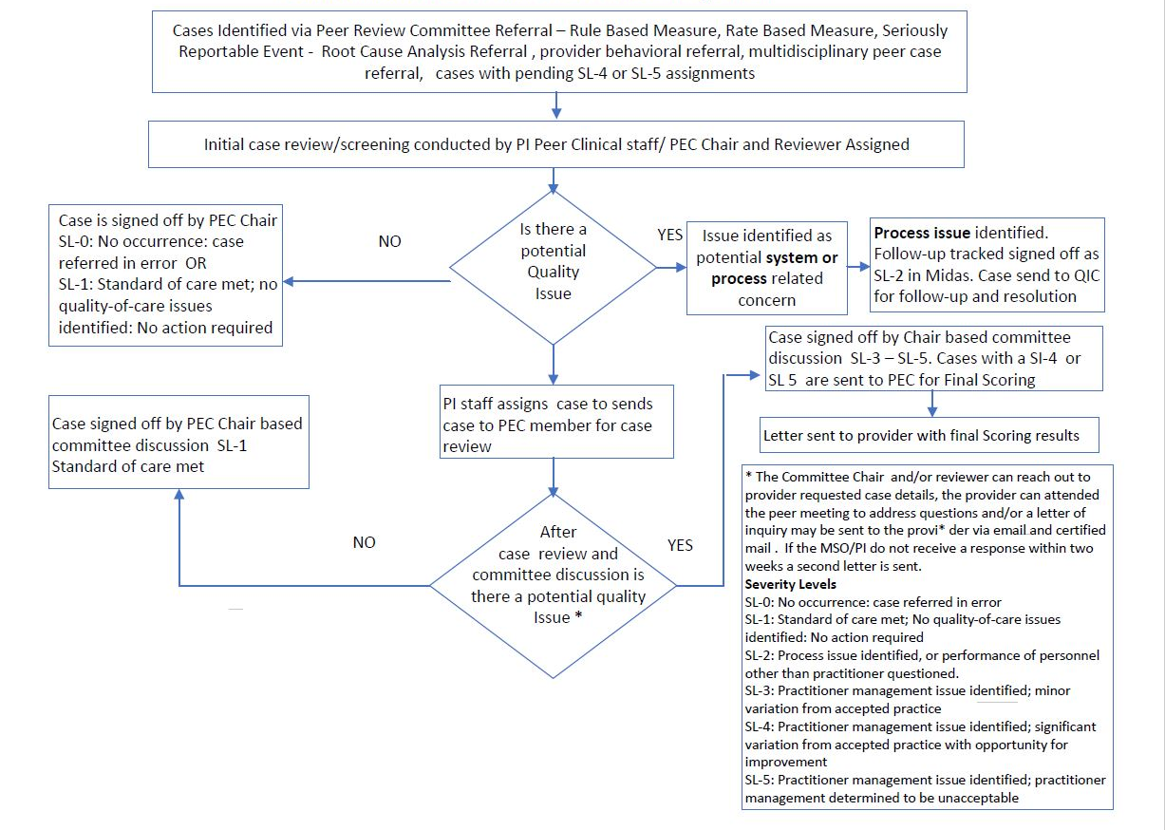

ONGOING PROFESSIONAL PRACTICE EVALUATION (OPPE)

OPPE is the ongoing monitoring of practitioners and providers to assess the quality of care delivered and to ensure patient safety. The results of - every 12 months review by the Department Chairman and any recommended actions will be documented in the minutes of the Supervisory Committee and are subject to review by the Medical Executive Committee. OPPE may be supported by data from coded records (Midas Statit Provider Scorecards and Quality Analytics), by the results of concurrent practitioner review or by summative observational qualitative assessment.

OPPE Review Process Steps Using Midas Statit Profiles and Data Source

- The PI Department will be responsible for preparing individual practitioner OPPE profile reports via the Midas Statit Physician Profile and Review (PPR) database twice each year. Attribution to individual practitioners will include their role as attending provider, procedural provider, and specialty provider as defined in Midas Statit (PPR) database based on coded medical records. Midas Statit (PPR) allows for comparison of provider performance with that of their peer group. In addition to providing a profile with performance and quality metrics, Midas Statit PPR provides aggregated trend information for each indicator in the profile. Midas comparisons enable clinical users to stratify performance compared with peers and adjust for patient-centered risk by using the Midas Risk Adjusted Model in the Midas Comparative Measurement System (CPMS). The Midas Risk Adjusted Model creates unique probabilities and expected values for each encounter based on patient centered demographics and claims data.

- The data elements in the OPPE review may include:
- Case Volume and Length of Stay (LOS)
- Readmission rates
- Case Mix and Case Mix Index
- Mortality
- Complications of care
- Primary caesarean section rate
- Medical Records compliance
- Peer Review results
- Hospital Patient Safety and Quality Indicators
- Hospital Acquired Conditions

- Each Department Chair will identify critical OPPE metrics in two categories: 1) measures with sufficient volume for individuals to make valid statistical statements about variation (e.g., LOS); 2) high impact areas were singular events (e.g., Core Measures fallouts and HAC events) warrant notice.

- The PI Department will review of the profiles screening for outliers in critical metrics or other concerning patterns.
  - The PI reviewer will review to determine indicators in a profile meet 100 % of the targets in Midas Statit PPR- Green
  - If the profile meets the set targets, the reviewer will flag the profile as “exceptional or acceptable performance.”
  - If the profile falls outside of the minimum % of targets met- Red, the profile will be flagged by the pre-reviewer and reviewed with the Department Chair

- The steps in the follow up by the Department Chair include:
  - Review of any profile that requires follow up
  - Review and discussion with the practitioner on cases requiring follow up
  - Documentation on profiles requiring follow up
  - Submission and storage of profile results in Midas Statit

OPPE – Process Steps Using EPIC Data Source and Assessment Check-off Process

Low and No Volume Provider Profiles

The Department of Radiology Envision OPPE also uses a quality peer review process based on standardized random over read of medical images. These reports are sent the Holy Cross Health PI Department, Cases that are identified by Envision as having potential clinical impact and review by the Holy Cross Health Peer Review Committee. Aggregate overread Radiology data is also reported at the Holy Cross Quality Improvement Council

The Department of Pathology conducts routine over reads of surgical pathology and concordance of frozen and final diagnoses for surgical pathology. Significant disagreements are reviewed, and any required actions are followed up by the Department Chair. Aggregate overread Pathology data is also reported at the Holy Cross Quality Improvement Council

Attribution of outcomes to individual practitioners is problematic when care is delivered by closely integrated group practice over a prolonged course of care. This includes neonatology practice, intensive care, and many consultative specialists. In those cases, OPPE may consist of the Department Chair providing a summative assessment of acceptability or concern based upon direct observation, review of shared cases, peer review results and patient concerns.

Evaluation of Nurse Practitioners (NP) and Physician Assistants (PA) is not supported by Midas Statit as they are rarely identified as attributable practitioners in any capacity. The care that they provide is subject to concurrent oversight or knowledge by a number of other practitioners. OPPE of NPs and PAs is a summative assessment of acceptability or concern based upon direct observation and review of shared cases by supervising practitioners.
True No Volume (without case volume in EPIC or Midas Statit) will be noted in Midas Statit. Provider list is sent to Medical Staff office to have external Quality Documentation obtained and stored in MSOW.

Sample OPPE Form NP/PA, Anesthesia, Radiology (office.com)

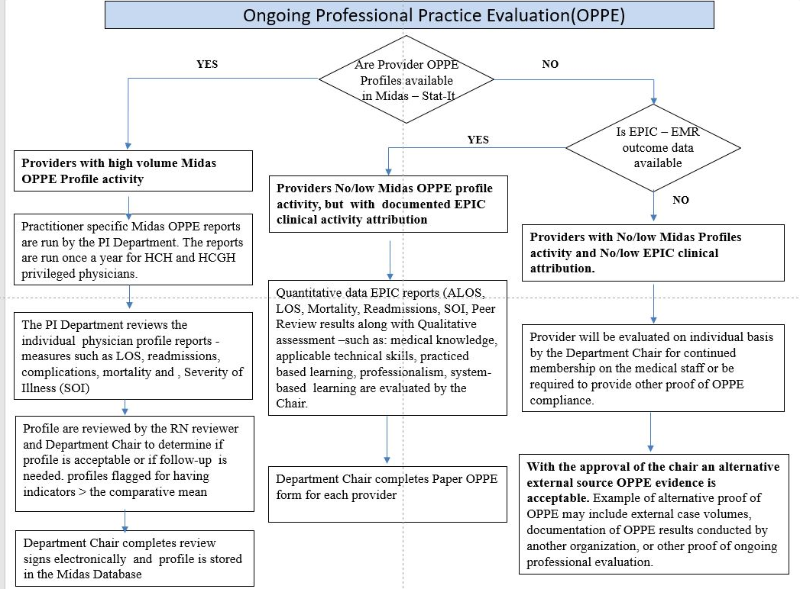

Focused professional practice evaluation (FPPE)

Focused professional practice evaluation (FPPE) refers to an evaluation of privilege-specific competence of a practitioner. A privileging FPPE (pFPPE) is performed when a practitioner does not have documented evidence of competently performing a requested privilege. This is part of an initial credentialing and privileging process but also includes a request for expansion of privileges for a previously credentialed practitioner. An administrative FPPE (aFPPE) may be conducted when a question arises regarding a practitioner’s ability to provide safe, high-quality patient care within the scope of previously granted privileges. The MEC has ultimate oversight of both the pFPPE and the aFPPE processes.

Privileging FPPE (pFPPE)

The Department Chair is responsible for the reviewing the pFPPE profile, and for making recommendations to the Credentials Committee for appointment and the scope of privileges for each applicant. The pFPPE plan is designed to be consistent for applicants with similar training and experience. Initial Privileging FPPE (pFPPE) cycle should start within 3 months of privileging and the Department Chair is expected to review within two weeks of receiving the profiles from Medical Staff Office. The pFPPE Midas profiles are run each month, reviewed by Chair and MS pFPPE completed. If a provider does not have case volume the providers pFPPE profile is run each month until case volume is above 5 cases.
If case volume does not reach 5 cases during the 2-year Credentialing period and an pFPPE not completed privilege’s will be voluntarily relinquished by the practitioner. The practitioner will immediately stop exercising said privileges. Privileges relinquished as a result of an incomplete pFPPE are not considered an adverse privileging action and will not be reported to regulatory agencies. The practitioner will not be entitled to a hearing or other procedural rights as set forth in the medical staff bylaws or the fair hearing and appeal policy for any privilege that is voluntarily relinquished due to an incomplete, expired pFPPE. The practitioner may reapply for privileges and is subject to a new pFPPE process.

If during the pFPPE process the medical staff leadership is notified of concerns about the pFPPE practitioner’s competence to perform specific clinical privileges or about the care of a specific patient, the Department Chair will review the relevant medical records and either continue or modify the pFPPE plan or refer to the Departmental Review or Supervisory Committee for actions in accordance with medical staff bylaws.

Privileging FPPE (pFPPE) Profile Design

The following six broad categories as a framework for the pFPPE review
- Patient Care
- Medical/clinical knowledge
- Practice-based learning and improvement.
- Interpersonal and communication skills
- Professionalism
- Systems- based practice
- Outcomes data

Privileging FPPE (pFPPE) -Process
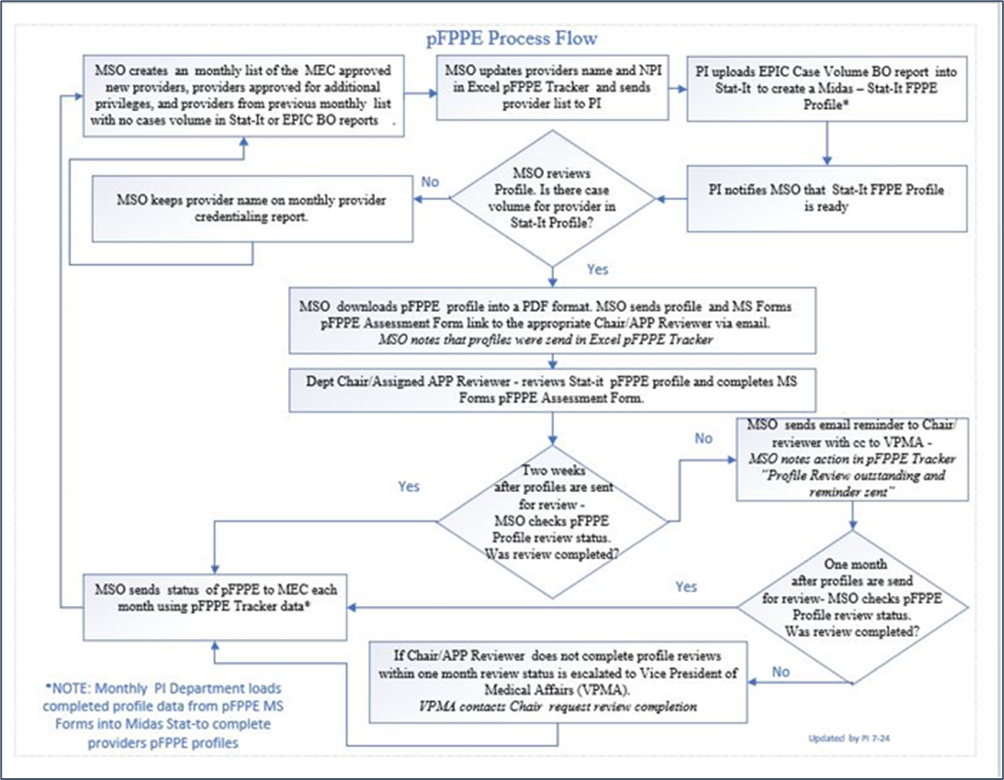

SAMPLE: HCH-HCGH Privileging FPPE (pFPPE) Form for APPs (office.com)

SAMPLE: HCH-HCGH Privileging FPPE (pFPPE) Form for Medical Providers (office.com)

Administrative FPPE (aFPPE)

An administrative FPPE (aFPPE) may be conducted when a question arises regarding a practitioner’s ability to provide safe, high-quality patient care within the scope of previously granted privileges. Based on input from individual practitioners, staff, practitioner specific trended data including OPPE data, concerns raised by individual case reviews, or based upon executive concerns from the Department Supervisory Committee, President of the Medical Staff, Hospital President Chief Medical Officer, Chief Clinical Officer an aFPPE may be initiated.
The results of such an administrative FPPE may be used in the credentialing process or to initiate an involuntary modification or loss of privileges. Such adverse actions are reportable to the National Practitioner Data Bank and the State Board of Medicine and are subject to hearing and appeal in accordance with Medical Staff bylaws.

MEC is responsible for informing the provider of the plan to conduct a aFPPE The Department Chair is responsible for designing the aFPPE plan, assigning medical staff members to monitor performance, reviewing the data collected, and making recommendations to the MEC based on consultation with Medical Staff leadership and the CMO concerning privileges for the individual practitioner. The Chair and MSO of responsible for tracking aFPPE status and reporting status to MEC monthly.

Administrative FPPE (aFPPE) Plan Design

In developing an aFPPE plan, consideration should be given to:
- Identification of areas of concern
- Defining the monitoring approach (e.g., case selection: prospective, concurrent or retrospective case review) record review, direct observation
- Type of assessment (e.g., qualitative, or quantitative)
- Volume or number of cases to be monitored (percentage of cases, number of cases per month, all cases
- Monitoring time frame and duration
- Outcomes measures that will be used in the plan
- Comparative peer data and prior evaluations
- Applicable professional standards

If during the aFPPE process the medical staff leadership is notified of concerns about the practitioner’s competence to perform specific clinical privileges or about the care of a specific patient, the Department Chair will review the relevant medical record(s) and either continue or modify the aFFPE plan or refer to the Departmental Review or Supervisory Committee for actions in accordance with medical staff bylaws.

Administrative FPPE (aFPPE) -Responsibilities of Department members

Department members are assigned to evaluate the practitioner under review. The role is that of an evaluator—to review and/or observe cases—not of a supervisor or consultant. The practitioner who is serving solely in this monitoring function is indemnified in accordance with medical staff bylaws. Evaluators must be members in good standing of the medical staff of Holy Cross Hospital, must practice in the same or related specialty as the requesting practitioner, and must have unrestricted privileges to perform any specific procedure(s) to be monitored. As required by the aFPPE plan, evaluators will observe the procedure being performed, monitor management of admissions, or review the completed medical record following discharge and complete evaluation forms.

The evaluator will ensure the confidentiality of the monitoring results and forms and will submit a summary report at the conclusion of the monitoring period. If, at any time during the monitoring period, there are concerns about the practitioner’s competence to perform specific clinical privileges or to provide care appropriate for his/her specialty, the evaluator will promptly notify the Department Chair.

All members of the active medical staff have a responsibility to serve as FPPE evaluators when asked to do so. Repeated refusal to accept assignment or to fulfill FPPE obligations will be referred to the Department Supervisory Committee.

Administrative FPPE (aFPPE) -Responsibilities of the practitioner undergoing aFPPE:

In accordance with the aFPPE monitoring plan, the practitioner will notify the evaluator(s) of cases in which care is to be evaluated prospectively or concurrently. For elective surgical or invasive procedures where observation is required, the practitioner must secure agreement from an evaluator to attend the procedure. The practitioner will provide the evaluator with necessary information not available in the electronic medical record about the patient’s clinical history; pertinent physical findings, lab, and x-ray results; the planned course of treatment or management.

The aFPPE practitioner will have the prerogative of requesting a change of evaluator from the Department Chair if a disagreement adversely affects his or her ability to complete the monitoring plan timely and satisfactorily. The Department Chair will make recommendations to MEC and the Credentials Committee for final action.

The aFPPE practitioner will inform the Department Chair of major complications associated with the privileges being monitored as part of aFPPE. This includes cases that will be referred to Peer Review based on Departmental criteria for the requested privileges.

