

**Social Posts – Safer Holiday Gatherings and Travel**

**CO**RONA**VI**RUS **D**ISEASE 2019   
(COVID-19)

|  |
| --- |
| **Audience:** MarComm colleagues to post on social media |
| **Revision Date:** 12/17/2021 |
| **Version:** # 1 |
| **COVID-19 Response Team Owner:** Clinical and Operations |
| **Date of Last Review:** 12/17/2021 |

Social Media Reminders to Celebrate Safely this Holiday Season

**Twitter - Holiday Overview**

The holiday season is here and with the #COVID19 pandemic still in full force it’s import that you stay safe when celebrating. Remember to get vaccinated/booster, wear a mask, social distance and wash your hands.

Keep yourself and others protected: [Holiday Tips (cdc.gov)](https://www.cdc.gov/coronavirus/2019-ncov/daily-life-coping/holidays/celebrations.html)

**Facebook/LinkedIn – Holiday Overview**

Holiday tradition are important for families and children, but we must stay diligent in the ever-going COVID-19 pandemic. Here are the best ways to minimize COVID-19 risk ⤵️

◾️ Get a COVID-19 vaccine/booster as soon as you can

◾️ Wear a mask that covers your nose and mouth to help protect yourself and others

◾️ Stay 6 feet apart from others who don’t live with you

◾️ Avoid crowds and poorly ventilated indoor spaces

◾️ Test to prevent spread to others

◾️ Wash your hands often with soap and water. Use hand sanitizer if soap and water aren’t available

Learn more: [Holiday Tips (cdc.gov)](https://www.cdc.gov/coronavirus/2019-ncov/daily-life-coping/holidays/celebrations.html)

**Social Graphic – Holiday Overview**

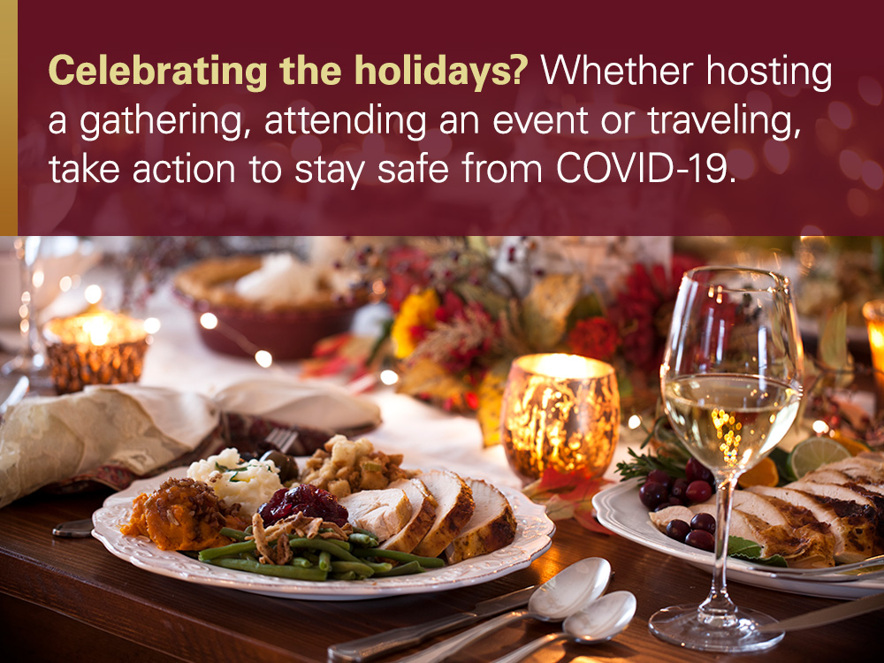

**Twitter – Hosting Holiday Gathering**

Are you hosting a holiday gathering this year? Your guests and you should socially distance, wear masks and wash your hands. Attendees should stay home if sick.

Keep yourself and others protected: [Holiday Tips (cdc.gov)](https://www.cdc.gov/coronavirus/2019-ncov/daily-life-coping/holidays/celebrations.html)

**Facebook/LinkedIn – Hosting Holiday Gathering**

Are you hosting a holiday gathering this year? If so, here are the best ways to minimize COVID-19 risk ⤵️

◾️ Encourage guests get the vaccine/booster

◾️ Remind guests to stay home if they are sick

◾️ Encourage social distancing

◾️ Wear masks

◾️ Clean hands often

◾️ Limit the number of people handling or serving food

◾️ Limit contact with commonly touched surfaces or shared items

Learn more: [Holiday Tips (cdc.gov)](https://www.cdc.gov/coronavirus/2019-ncov/daily-life-coping/holidays/celebrations.html)

**Social Graphic – Hosting Holiday Gathering**

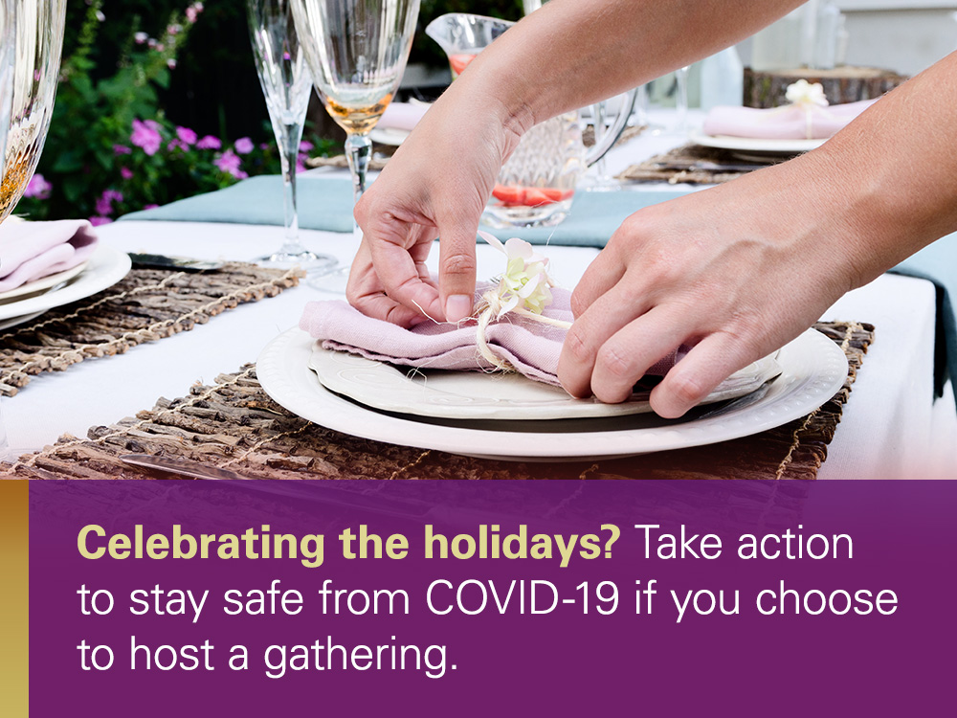

**Twitter – Attending Holiday Gathering**

Choosing to celebrate the holidays at a loved one or friend’s home? With the rising #COVID19 cases, make sure you get vaccinated/a booster, wear a mask, social distance, and wash your hand. And stay home if you’re sick.

Keep yourself and others protected: [Holiday Tips (cdc.gov)](https://www.cdc.gov/coronavirus/2019-ncov/daily-life-coping/holidays/celebrations.html)

**Facebook/LinkedIn – Attending Holiday Gathering**

Choosing to celebrate the holidays at a loved one or friend’s home? If so, here are the best ways to minimize COVID-19 risk ⤵️

◾️ Get vaccinated and/or a booster

◾️ Prepare before you go

◾️ Use social distancing and limit physical contact

◾️ Wear a mask

◾️ Limit contact with commonly touched surfaces or shared

Learn more: [Holiday Tips (cdc.gov)](https://www.cdc.gov/coronavirus/2019-ncov/daily-life-coping/holidays/celebrations.html)

**Social Graphic – Attending Holiday Gathering**

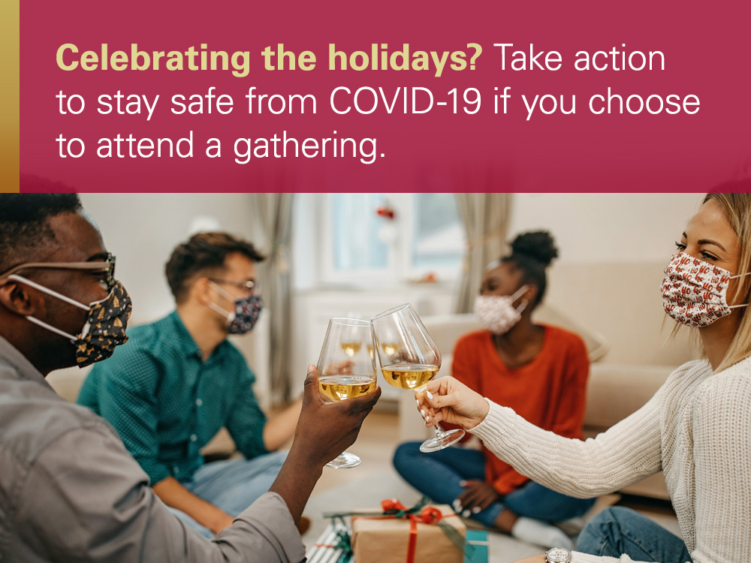

**Twitter – Holiday Travel**

‘Tis the season. AAA estimates more than 109 million Americans will travel between Christmas and New Year’s. With #COVID19 still in full force, remember to get vaccinated/a booster, wear a mask, social distance, and wash your hands when traveling.

Learn More: [Holiday Tips (cdc.gov)](https://www.cdc.gov/coronavirus/2019-ncov/daily-life-coping/holidays/celebrations.html)

**Facebook/LinkedIn – Holiday Travel**

‘Tis the season. AAA estimates more than 109 million Americans will travel between Christmas and New Year’s. With the COVID-19 pandemic still in full force, traveling can increase your risk of contracting the virus. Here’s what you can do to keep yourself safe while traveling ⤵️

◾️ Get vaccinated and/or a booster

◾️ Wear a mask

◾️ Use social distancing and limit physical contact

◾️ Wash your hands often

◾️ Clean and disinfect

◾️ Avoid crowds

◾️ Cover coughs and sneezes

◾️ Monitor health daily

Learn more: [Holiday Tips (cdc.gov)](https://www.cdc.gov/coronavirus/2019-ncov/daily-life-coping/holidays/celebrations.html)

**Social Graphic – Holiday Travel**

