

**THS Food & Nutrition Division -**

**Adult Enteral/Parenteral Guidance**

**CO**RONA**VI**RUS **D**ISEASE 2019   
(COVID-19)

|  |
| --- |
| **Audience:** Food & Nutrition leaders, ministry stakeholders, FANS Registered Dietitians |
| **Revision Date:** 11/24/20 |
| **Version:** 3 |
| **COVID_19 Response Team Owner:** George Cranmer |
| **Date of Last Review:** 11/24/20 |

**What’s Changed:** [Summarized Changes]

* Key stakeholders identified
* Focus on surge requirements
* Referred to the American Society for Parenteral and Enteral Nutrition (ASPEN) and the Academy of Nutrition and Dietetics (AND) with links to ensure latest, evidenced based recommendations are sourced.
* Emphasized need to coordinate with Clinical Engineering, Infection Control and Nursing to clean and centralize feeding pumps to improve tracking and access as this was found to be routinely problematic resulting in pump shortages
* Emphasize pump and closed system supply/feeding devices are now on back order and/or in short supply so ability to pivot to an open system maybe imminent
* Work with RDN to find suitable replacements when enteral product and or supplies/feeding devices are not available.

During COVID-19 surge, adjustments to the provision of Enteral and Parenteral Nutrition and their related procedures and standards may be necessary in order to optimize the nutritional care for our patients. Key stakeholders, including but not limited to Local HM Incident Command, Food and Nutrition Services Team, Supply Chain, Clinical Engineering, Pharmacy, Nursing, and Infection Control should be involved. It is understood in surge situations products and supplies will constantly shift.

Procurement and Administration

1. Refer to local Clinical Engineering, Supply Chain or department overseeing the inventory status of feeding pumps.
   1. Ensure all existing feeding pumps are accounted for and in good working order.
   2. Recommend forecasting pumps, spike sets and feeding tubes based on your anticipated increase in critical care beds: 10%, 20% or 30%.
      1. While pumps may be in short supply due to back orders, refer to Table 2 for potential alternative manufacturers and model information. With ordering any additional pumps, consider the need and availability of spike sets.
      2. Ordering of pumps should be coordinated with Food & Nutrition Services leadership, Supply Chain, and Clinical Engineering. ***NOTE: All pumps must be registered, tested and tagged with Clinical Engineering prior to being placed into service.***
   3. Coordinate with Clinical Engineering, Infection Control, and Nursing to clean and centralize feeding pumps to improve the tracking and accessibility of pumps.
      1. Infection Control and Nursing should review and approve all pump cleaning guidance and Tube Feeding Product Handling Guidelines (see Table 2).
2. Determine the gap that exists between available pumps and surge demands. Plan to fill with gravity feed systems or bolus/syringe feedings if a pump and/or spike shortage exists. Each ministry site should maintain a back-up supply of gravity bags (includes tubing), spike sets, bolus/flushing syringes, poles and cans/cartons of formula.
3. Refer to Table 3 for the THS-FANS Standardized Enteral Formulary and recommended increase percentage. Note Vital HP, Promote, Osmolite 1.2 and Nepro have been used predominantly in COVID-19 patients to date. You should anticipate an increased utilization of these products and increase inventory based on your anticipated increase in COVID-19 patients who are unable to consume foods orally.
4. Post surge, work with team and vendor to move excess stock that cannot be utilized prior to expiration.

Choosing Feeding Modalities

1. Determine feeding modalities based on patient type, supply availability, location and electrical needs. Guidance is provided in Decision Tree for Tube Feeding Product and Feeding Modality (Table 4).

**Prioritizing Electric Tube Feeding Pumps**

1. Critically ill COVID-19 patients on trophic tube feeding rate.
2. All critically ill patients on trophic rate.
3. Patients with post pyloric feeding tube.
4. Critically ill COVID-19 patients requiring continuous TF.
5. All critically ill patients requiring continuous TF.
6. Reserve feeding pumps for critically ill patients when and if shortages in pumps or spike sets occur using the guidance to the right: “Prioritizing Electric Tube Feeding Pumps.”
7. In the event of a pump or spike set shortage, take the steps shown to the right to move to gravity or bolus feeds: “Gravity or Bolus Feeds.”

**Gravity or Bolus Feeds**

* Prioritize patients who need a pump
* Get patients off pumps where no longer required/essential:
  + Give intermittent gravity or bolus feeds
  + Transition to oral nutrition
* Consider Med Fusion Syringe Pumps

1. Med Fusion Syringe pumps may provide controlled feeding rate over a 6-hour period. These are commonly used in a NICU environment.
2. **Engage nursing educators** to train nursing colleagues on gravity feed and bolus/syringe feedings should it become primary feeding mode for COVID-19 patients or other patients relying on enteral nutrition. This is apt to occur in the event of a surge, supply shortages, limited electrical access and/or due to the potential relocation of these patients.
3. For guidance on feeding in prone position, gravity and bolus feeding, and overall nutrition support, refer to American Society for Parenteral and Enteral Nutrition (ASPEN) at [nutritioncare.org](http://www.nutritioncare.org/).
4. For gravity drip method, bore size of tubing and viscosity of formula may affect the drip rate. See Table 5 for instructions.
5. As supply availability changes between 8-ounce containers and 1000 mL bottles, correct product selection and safe food handling are imperative.
   1. 8-ounce containers should be preserved for gravity and bolus feeds as able.
   2. Identify the appropriate product and/or amount based on the feeding modality, and ability to dispense and store safely in the absence of waste.
   3. Any opened enteral product must be labeled with date and time opened.
   4. All opened and unused, refrigerated product must be used within 24 hours or discarded.
6. Consider delivering unopened products to common, centralized spaces to dispense to multiple patients to ensure product turnover and minimize waste.
7. Product that has entered patient's room may not be returned to the pantry or Food and Nutrition Services and must be discarded if not used.
   1. For products delivered to a centralized area on a COVID unit and have not entered any specific patient’s room, discuss with local Infection Control on returning products to kitchen.

Clinical Nutrition Guidelines

1. The Registered Dietitian (RDN) should order enteral nutrition within his or her scope of practice in a manner that is flexible and responsive to supply availability. This will spare provider time as feeding modalities change. The RDN will provide a clear order stating the preferred feeding modality yet include additional orders if this option is not available.
2. When placing orders, keep in mind the concept of bundled care to limit exposure.
   1. Consider grouping protein modular with other meds
3. Order Writing Example:

RDN Order Set Reads: Vital HP via ___ feeding tubeusing **pump** start feeds of ___ at ___, advance by ___ every __ hours to goal rate of ___.  Flush ___ mL q ___ hours or per patient's condition and requirements.

In the event that a pump feeding is not available, choose **gravity** drip feeds, adjust roller clamp to provide ___ drips per 15 seconds. Flush ___ mL q ___ hours or per patient's condition and requirements.

OR **bolus** feeds, provide ___ mL four times/day as tolerated. Total volume per day ___. Flush ___mL before and after each feeding or per patient's condition and requirements

* 1. For bolus feed, consider adjusting dosing frequency and bolus volume based on bundled care.

1. For parenteral nutrition, obtain a baseline inventory count of premixed parenteral nutrition bags (Clinimix) and/or compounding agents and capabilities.
   1. Understand the limitations of Clinimix as it pertains to the COVID-19 patient due to fluid and electrolyte compositions and discuss alternative solutions with providers
2. Below are a few points to consider when feeding COVID-19 patients. Additionally, Table 6 outlines the Decision Tree for Nutrition Interventions in the COVID-19 patient.

* Timing of Delivery: The goal is to initiate early EN within 24-36 hours of admission into the ICU or within 12 hours of intubation on ventilator if hemodynamically stable (stable vasopressors with sustained mean arterial pressure of >=65 mmHg.)
* Monitoring Tolerance: Checking gastric residual volume (GRV) should not be utilized in critically ill patient with COVID-19.  It is not reliable for detection of delayed gastric emptying and to decrease the risk of disease transmission to the healthcare provider.
* Feeding under Prone Positioning: Note feeding modality in prone position warrants further discussion amongst the health care team. May prioritize pumps for these patients. Keep HOB elevated (reverse Trendelenburg) to at least 10-25 degrees.
* Feeding During ECMO: Consider starting early trophic EN with close monitoring of enteral feeding intolerance.  Advance to goal slowly over the first week.

1. In the event of product backorders, the provider will consult the RDN for a suitable replacement.

3Additional Resources



See Lippincott for Gravity and Bolus Feed Resources

See Healthstream for Enteral Feeding Resources

Quick Nursing References

   

APPENDIX

**Table 1: Pump Manufacturer and Model Information**

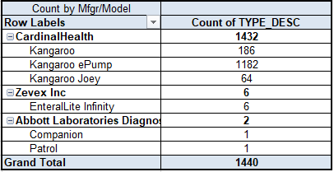

**Table 2: Tube Feeding Product Handling Guidelines**

|  |  |
| --- | --- |
| **Product Type\*** | **Hang Time** |
| Closed-system, Ready to Hang (RTH) w/ same spike set | 48 hours |
| RTH w/changed spike set | 24 hours |
| Open system (RTH or cartons poured into a bag) | 8 hours |
| Powdered formulas | 4 hours |

* All opened unused formula should be refrigerated upon opening and used within 24 hours.

**Table 3: THS-FANS Standardized Enteral Formulary**

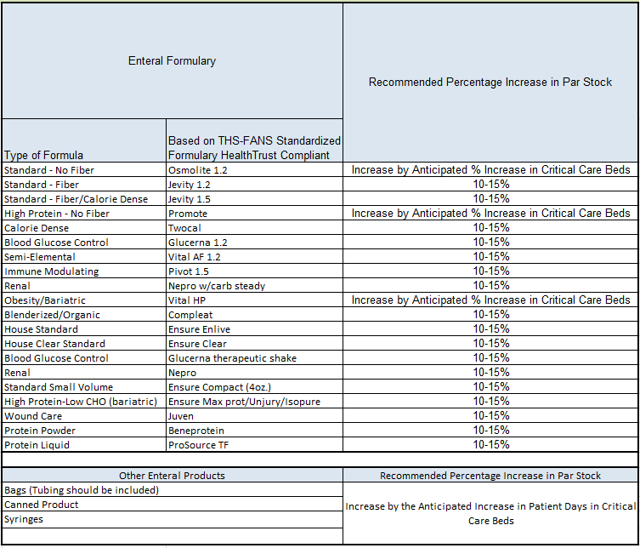

**Table 4: Decision Tree for Tube Feeding Product and Feeding Modality**

Gravity Drip

TF Pump

Bolus via Syringe

Preferred feeding modality in critically ill patients and patients on trophic feeding unless pump or spike set shortage exists.

Assume bolus feeds are provided or four times daily specific to RHM bundled care schedule

May not be used with Nepro or Two Cal HN. May not work well at rates less than 100 mL per hour or 6-8 drops per 15 seconds.

RDN Order Set Reads: Tube feeding via ___ feeding tube using syringe bolus feeds, provide ___ mL four times/day as tolerated. Total volume per day ___.

RDN Order Set Reads: Tube feeding via ___feeding tube using **gravity** drip feeds, adjust roller clamp to provide ___ drips* per 15 seconds. Total volume per day _____. Refer to gravity drip chart

RDN Order Set Reads: Tube feeding via __ feeding tube using **pump.** Start feeds of ___ at ___, advance by ___ every __ hours to goal rate of ___.  Total volume per day ___.

*Note Abbott cannot guarantee drip rates <100 mL/hour.

Minimum water flushes are needed to maintain tube patency and hydration needs.

RDN Order Set Reads: TF Pump: Flush ___ mL q ___ hours or per patient's condition and requirements

RDN Order Set Reads: Bolus Via Syringe: Flush __ mL before and after each feeding or per patient's condition and requirements

RDN Order Set Reads: Gravity Drip: Flush ___mL before and after each feeding or per patient's condition and requirements

Guidance for Large, Offsite Centralized Covid-19 Sites

**-----------------------------------------------------------------------------------------------------------------------------------------------------**

Gravity Drip may be optimized.

Bolus via syringe may be optimized.

TF Pump may not be practical due to limited electrical access.

**Table 5: Gravity Feeding Flow Rate (adopted from Abbott)**

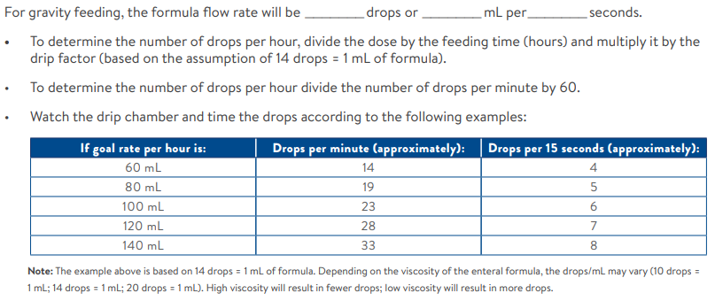

**Table 6: Decision Tree for Nutrition Intervention in the Covid-19 Patient**

Is GI tract functional?

No

Yes

When GI symptoms are present, early use of PN should be considered.

Can patient adequately eat per mouth?

No

Yes

Begin Enteral Nutrition within 24-36 hours admission into ICU or 12 hours on ventilator

Oral Diet. May benefit from Nutritional Supplements. Monitor electrolytes & fluid status

If unable to achieve requirements via EN, consider PN initiation.

Options Include but are not limited to:

Vital HP,

Promote,

Osmolite 1.2

Or Nepro in the instance of renal dysfunction.

protein