**COVID-19 Vaccine FAQ Social Posts pt.2**

Social Post #1: COVID-19 Vaccine FAQ: Can a COVID-19 vaccine make me sick with COVID-19?

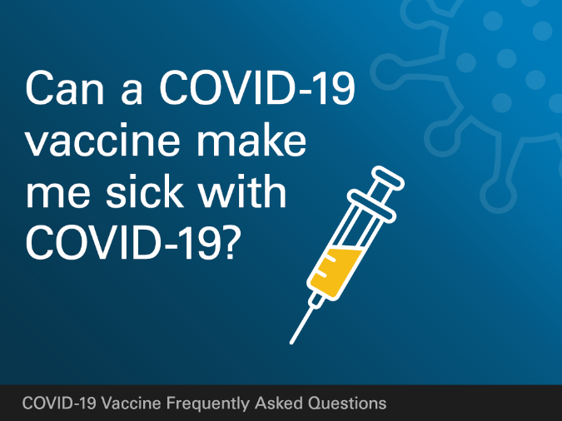

**COVID-19 FAQ: Can a COVID-19 vaccine make me sick with COVID-19?**  
No. None of the authorized COVID-19 vaccines or ones currently in development in the United States contain the live virus that causes COVID-19. This means that a COVID-19 vaccine cannot make you sick with COVID-19. #COVID19 #vaccine

Social Post #2: COVID-19 Vaccine FAQ: After getting a COVID-19 vaccine, will I test positive for COVID-19 on a viral test?

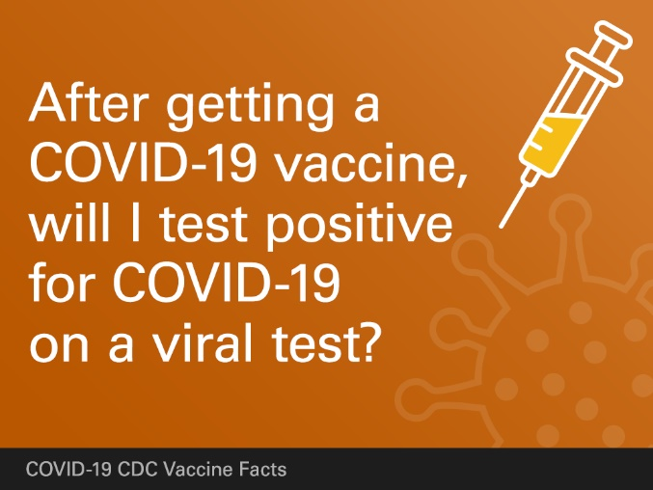

**COVID-19 FAQ: After getting a COVID-19 vaccine, will I test positive for COVID-19 on a viral test?**No. Neither the recently authorized COVID-19 vaccines nor others currently in clinical trials in the United States can cause you to test positive on viral tests, which are used to see if you have a current infection.​If your body develops an immune response, there is a possibility you may test positive on some antibody tests. Antibody tests indicate you had a previous infection and that you may have some level of protection against the virus. Experts are currently looking at how COVID-19 vaccination may affect antibody testing results. #COVID19 #vaccine

Social Post #3: COVID-19 Vaccine FAQ: If I have already had COVID-19 and recovered, do I still need to get vaccinated with a COVID-19 vaccine?

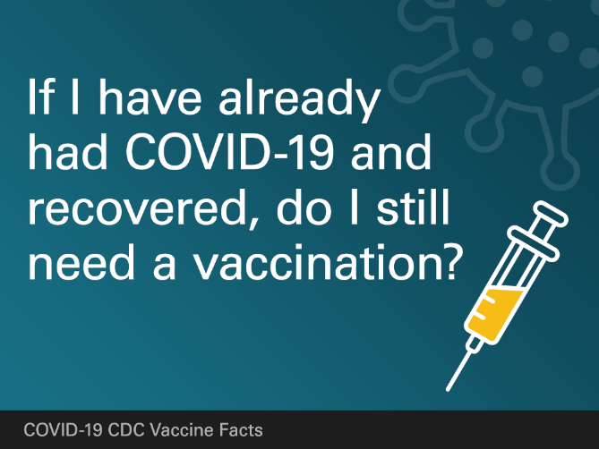

**COVID-19 Vaccine FAQ: If I have already had COVID-19 and recovered, do I still need to get vaccinated with a COVID-19 vaccine?**

Yes. Due to the severe health risks associated with COVID-19 and the fact that re-infection with COVID-19 is possible, vaccine should be offered to you regardless of whether you already had COVID-19 infection. #COVID19 #vaccine

Social Post #4: COVID-19 Vaccine FAQ: Will a COVID-19 vaccination protect me from getting sick with COVID-19?

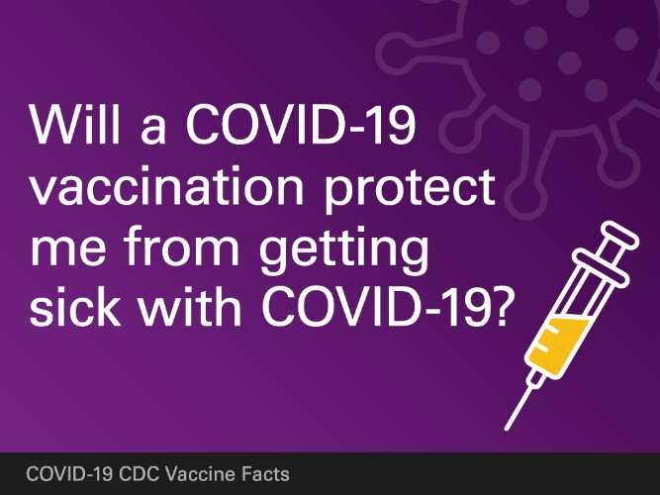

**COVID-19 Vaccine FAQ: Will a COVID-19 vaccination protect me from getting sick with COVID-19?**Yes. COVID-19 vaccination works by teaching your immune system how to recognize and fight the virus that causes COVID-19, and this protects you from getting sick with COVID-19. Being protected from getting sick is important because there is no way to know how COVID-19 will affect you, even if you don’t have an increased risk of developing severe complications. #COVID19 #vaccine

Social Post #5: COVID-19 Vaccine FAQ: Will a COVID-19 vaccine alter my DNA?

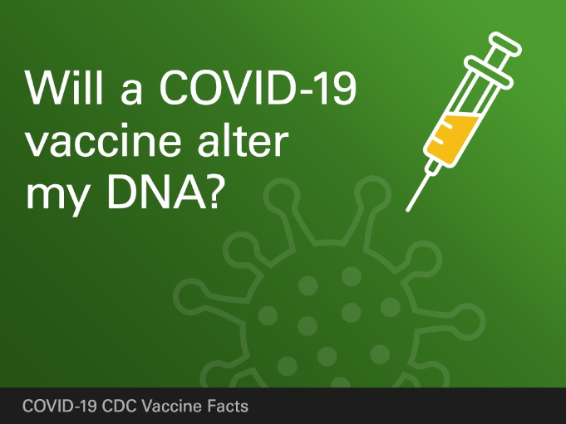

**COVID-19 Vaccine FAQ: Will a COVID-19 vaccine alter my DNA?**No. COVID-19 mRNA vaccines do not change or interact with your DNA in any way. mRNA vaccines teach our cells how to make a protein that triggers an immune response. The mRNA from a COVID-19 vaccine never enters the nucleus of the cell, which is where our DNA is kept. This means the mRNA cannot affect or interact with our DNA in any way. #COVID19 #vaccine

Social Post #6: COVID-19 Vaccine FAQ: Is it safe for me to get a COVID-19 vaccine if I would like to have a baby one day?

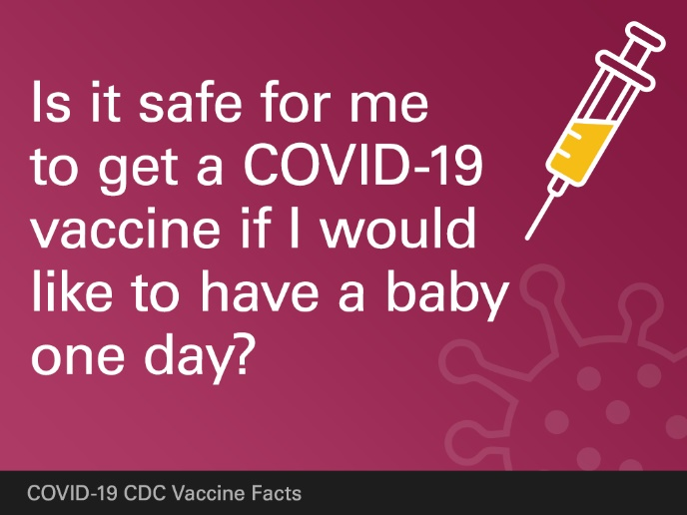

**COVID-19 Vaccine FAQ: Is it safe for me to get a COVID-19 vaccine if I would like to have a baby one day?**Yes. People who want to get pregnant in the future may receive the COVID-19 vaccine. Based on current knowledge, experts believe that COVID-19 vaccines are unlikely to pose a risk to a person trying to become pregnant. There is currently no evidence that antibodies formed from COVID-19 vaccination cause any problems with pregnancy. In addition, there is no evidence suggesting that fertility problems are a side effect of any vaccine. People who are trying to become pregnant now or who plan to try in the future may receive the COVID-19 vaccine when it becomes available to them. #COVID19 #vaccine