

**CO**RONA**VI**RUS **D**ISEASE 2019   
(COVID-19)

**Social Posts – Vaccine Comparison**

|  |
| --- |
| **Audience:** MarComm colleagues to post on social media |
| **Revision Date:** 3/8/2021 |
| **Version:** Version # 1 |
| **COVID-19 Response Team Owner:** Clinical and Operations |
| **Date of Last Review:** 3/8/2021 |

Which COVID-19 vaccine should I get?

**Which COVID-19 vaccine should I get?** All approved COVID-19 vaccines are safe and protect against severe illness, so it doesn’t matter which one you receive. The most important thing is to get vaccinated when it is your turn. It’s the most effective way to end the pandemic and protect yourself and others.

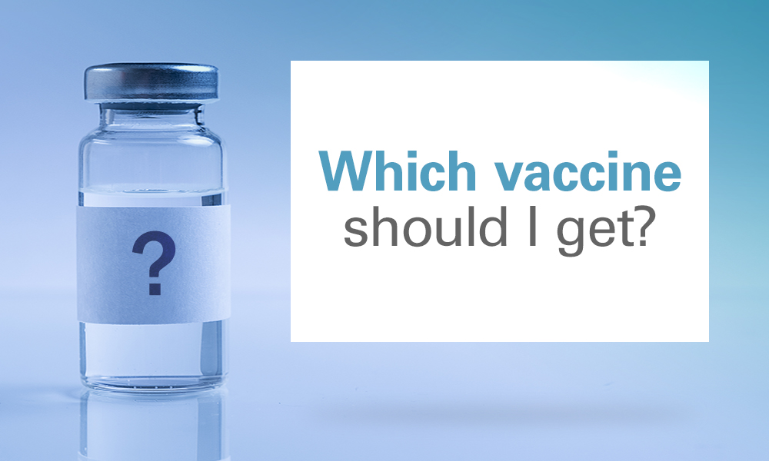(Which vaccine should I get_social media.jpg)

Vaccine comparison

There are now three COVID-19 vaccines being distributed. Here are the differences. Remember, all are extremely effective. The most important thing is to get the vaccine you can, as soon as it is your turn.

**Comparison:** <https://www.trinity-health.org/covid-19-resources/_assets/documents/clinical-guidance/vaccine/a-quick-glance-covid-19-vaccines.pdf>