

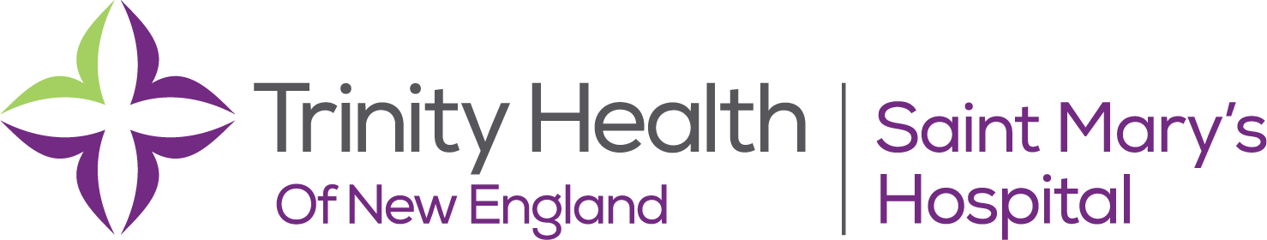

# Code of Conduct- Supplement for Medical Staff

As a member of the medical staff of a Trinity Health hospital, you serve as a trusted partner in the delivery of health care services to our patients and community. The Trinity Health Mission Statement calls us to serve together in the spirit of the Gospel as a compassionate and transforming healing presence within our communities. Guided by our Core Values, we are committed to the delivery of people-centered care that leads to better health care, improved health outcomes, and overall lower costs for our patients, residents, members and communities we serve.

Trinity Health has established a system-wide Integrity and Compliance Program to support all who work in our health care ministry in understanding and following the laws, regulations, professional standards, and ethical commitments that apply. The Trinity Health Code of Conduct describes behaviors and actions expected of all who work in Trinity Health- colleagues, physicians, suppliers, board members and others. This Supplement describes those areas of the Code of Conduct that have particular application to our relationship with you as a member of the hospital's medical staff. If you have any questions regarding this information, please contact your Medical Staff Office or the Integrity & Compliance Officer at your Ministry. The complete Code of Conduct is available online at http://www.trinity ­ health.org/documents/codeofconduct.pdf .

****

The following standards are expected of all clinical professionals who work in Trinity Health of New England, including members the medical staff:

# Professionalism

* Deliver people-centered, quality health care services with compassion, dignity and respect for

each individual.

* Deliver services without regard to race, color, religion, gender, sexual orientation, marital status, national origin, citizenship, age, disability, genetic information, payer source, ability to pay, or any other characteristic protected by law.
* Maintain a positive and courteous customer service orientation.
* Demonstrate the highest levels of ethical and professional conduct at all times and under all

circumstances.

* Speak professionally and respectfully to those with whom you work and whom you serve.
* Respond to requests for information or assistance in a timely and supportive manner.
* Behave in a manner that enhances a spirit of cooperation, mutual respect, a supportive team environment and trust among all members of the team.

2 This Code of Conduct is effective: March 1, 2018.

* Deliver services in accordance with all professional standards that apply to your position.
* Create and maintain complete, timely and accurate medical records consistent with medical staff bylaws.
* Protect the privacy and confidentiality of all personal health information- electronic, paper or verbal- you may receive.
* Maintain appropriate licenses, certifications and other credentials required of your position.
* Abstain from inappropriate physical contact or inappropriate behavior with others.
* Report any harassment, intimidation or violence of any kind..
* Maintain a safe work environment by performing your duties and responsibilities free from the influence of drugs or alcohol.
* Protect the confidentiality of all peer review information.

# Commitment to Providing Quality Care that is Safe and Medically Appropriate

* Commit to safety: every patient, every time.
* Speak up when you see a quality or safety issue and discuss mistakes you see with others so we

can learn how to prevent future mistakes.

* Adhere to clinical guidelines and protocols that reflect evidence-based medicine.
* Actively engage and support efforts to improve quality of care, including organization-approved technology advancements.
* Actively participate in initiatives to improve care coordination between and among caregivers,

community support agencies and other providers.

* Actively participate in initiatives to improve the health of the community as a whole.

# Advocating for Our Patient's Needs

* Provide comfort for our patients, including prompt and effective response to their needs.
* Communicate clinical information to patients and their designees in a clear and timely manner.
* Discuss available treatment options openly with patients,or their designees and involve them in decisions regarding their care.
* Provide care to all patients who arrive at your facility in an emergency, as defined by law, regardless of their ability to pay or source of payment.
* Clearly explain the outcome of any treatment or procedure to patients, or their designees, especially when outcomes differ significantly from expected results.
* Respect patient advance directives.
* Address ethical conflicts that may arise in patient care, including end-of-life issues, by consulting your organization's medical ethics committee or Mission Officer.
* Provide care that is consistent with the *Ethical and Religious Directives for Catholic Health Care Services.*

3 This Code of Conduct is effective: March 1, 2018.

# Stewardship of Resources

* Properly use and protect all resources including materials and supplies, equipment, staff time and

financial assets.

* Respect the environment and follow your organization's policies for the handling and disposal of

hazardous materials and infectious waste.

# Corporate Citizenship

* Act with honesty and integrity in all activities.
* Actively participate in training programs offered by your organization.
* Follow your organization's policies requiring the disclosure of outside activities or relationships that could represent a conflict of interest with your medical staff membership or role and any other responsibilities .
* Follow all requirements of Medicare, Medicaid, other federal and state health care programs, as well as those of commercial insurance companies and other third-party payers. These requirements generally involve:
  + Delivering high-quality, medically necessary and appropriate services. o Creating and maintaining complete and accurate medical records.
  + Submitting complete and accurate claims for services provided.
  + Protecting the privacy and security of health information we collect.
* Conduct all medical research activities consistent with the highest standards of ethics and integrity and in accordance with all federal and state laws and regulations, and your organization's Institutional Review Board policies.
* Immediately notify your Medical Staff Office if notified you have been excluded or debarred from participation in federal or state health care programs .

# Where to Find Help

If you have a question or concern about possible violations of law, regulation or the Code of Conduct you are encouraged to seek answers by contacting one of the following resources:

* Your Chief Medical Officer or Medical Staff Office: Ellen Polokoff, MD FACS
* Another member of your organization's senior management team
* Your Ministry's Integrity & Compliance Officer: Carlos Brown
* The Trinity Health Integrity and Compliance Line at 1-866-477-4661 or you may file a written

report online at www.mycompliancerepor t.com using access code "THO"

I acknowledge the Trinity Code of Conduct of the Medical Staff.

Signature

Date:_______________