

**CO**RONA**VI**RUS **D**ISEASE 2019   
(COVID-19)

**Social Posts – Vaccine Booster Doses**

|  |
| --- |
| **Audience:** MarComm colleagues to post on social media |
| **Revision Date:** 11/4/2021 |
| **Version:** Version #1 |
| **COVID-19 Response Team Owner:** Clinical and Operations |
| **Date of Last Review:** 11/4/2021 |

Post 1

Unsure if you should receive a COVID-19 booster dose? All who received the Johnson and Johnson vaccine should receive a booster dose at least 2 months after their initial dose, and the CDC recommends that higher-risk groups who received the Pfizer (Comirnaty) or Moderna vaccines also receive booster doses. For an overview of who should receive a booster dose, read more. [Link to <https://www.trinity-health.org/covid-19-resources/_assets/documents/clinical-guidance/vaccine/vaccine-boosters-for-adults.pdf>]



Post 2

With flu season arriving, some people have wondered if they are able to receive a COVID-19 vaccine and flu vaccine at the same time. The CDC states that it is safe to receive both vaccines during the same visit. Read more. [Link to <https://www.cdc.gov/flu/season/faq-flu-season-2021-2022.htm>]



Post 3

The COVID-19 vaccines remain highly effective in reducing serious illness, hospitalizations and deaths from COVID-19 infection. However, for some groups, booster doses are recommended to help strengthen the immune system’s response over time. Learn more. [Link to <https://www.cdc.gov/media/releases/2021/p1021-covid-booster.html>]

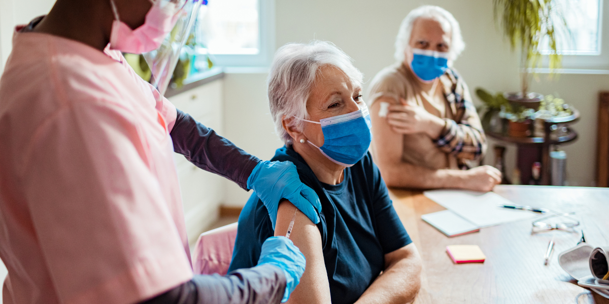

Post 4

What’s the difference between a third COVID-19 vaccine dose and a booster? Third doses are recommended for those who are immunocompromised at least 28 days after their second dose of the Pfizer or Moderna vaccine, as immunocompromised people may not build the same level of immunity as others. Booster doses are used to strengthen the immune system after the original vaccine response decreases over a longer period of time. Learn more about the timing of booster doses here. [Link to <https://www.trinity-health.org/covid-19-resources/_assets/documents/clinical-guidance/vaccine/vaccine-boosters-for-adults.pdf>]

